QUESTION 1:

INCLUDE Irvine32.inc

.data
no BYTE "Enter a number: ", 0
idx BYTE "Enter bit index 0-31: ", 0
res BYTE "Bit at index is: ", 0
number DWORD ?
index DWORD ?

.code
main PROC
mov edx, OFFSET no
call WriteString
call ReadInt
mov number, eax

mov edx, OFFSET idx
call WriteString
call ReadInt
mov index, eax

mov eax, number
mov ecx, index
shr eax, cl
and eax, 1

mov edx, OFFSET res
call WriteString
call WriteInt
call Crlf

exit
main ENDP
END main

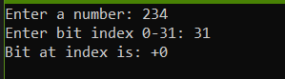
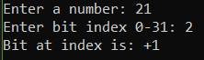

QUESTION 2:

INCLUDE Irvine32.inc

.data
menu BYTE " SHIFT & ROTATE CALCULATOR", 0Dh, 0Ah
BYTE "1. Multiply by 2 power n", 0Dh, 0Ah
BYTE "2. Divide by 2 power ", 0Dh, 0Ah
BYTE "3. rotate left", 0Dh, 0Ah
BYTE "4. rotate right", 0Dh, 0Ah
BYTE "5. exit", 0Dh, 0Ah
BYTE "select operation 1-5: ", 0

no BYTE "Enter the number: ", 0
n BYTE "Enter the value of n: ", 0
res BYTE "Result: ", 0
bin BYTE "Binary: ", 0
wrong BYTE "enter a correct choice", 0Dh, 0Ah, 0
byebye BYTE "Bye bye..thnx!", 0Dh, 0Ah, 0

number DWORD ?
n_value DWORD ?
choice DWORD ?

.code
main PROC
menu_loop:
call Crlf
mov edx, OFFSET menu
call WriteString
call ReadInt
mov choice, eax

cmp eax, 5
je exit_program

cmp eax, 1
jl invalid_choice
cmp eax, 4
jg invalid_choice

mov edx, OFFSET no
call WriteString
call ReadInt
mov number, eax

mov edx, OFFSET n
call WriteString
call ReadInt
mov n_value, eax

mov eax, choice
cmp eax, 1
je multiply_op
cmp eax, 2
je divide_op
cmp eax, 3
je rotate_left_op
cmp eax, 4
je rotate_right_op

multiply_op:
mov eax, number
mov ecx, n_value
shl eax, cl
jmp display_result

divide_op:
mov eax, number
mov ecx, n_value
shr eax, cl
jmp display_result

rotate_left_op:
mov eax, number
mov ecx, n_value
rol eax, cl
jmp display_result

rotate_right_op:
mov eax, number
mov ecx, n_value
ror eax, cl
jmp display_result

display_result:
call Crlf
mov edx, OFFSET res
call WriteString
call WriteInt
call Crlf

mov edx, OFFSET bin
call WriteString
call WriteBin
call Crlf

jmp menu_loop

invalid_choice:
mov edx, OFFSET wrong
call WriteString
jmp menu_loop

exit_program:
call Crlf
mov edx, OFFSET byebye
call WriteString

exit
main ENDP
END main
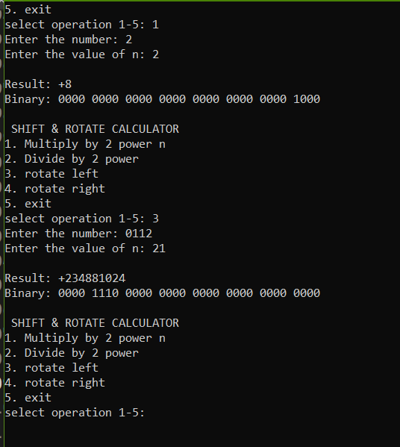

QUESTION 3:

INCLUDE Irvine32.inc

.data
array DWORD 9 DUP(?)
rowSums DWORD 3 DUP(?)

element BYTE "Enter element [", 0
row BYTE "][", 0
ends BYTE "]: ", 0

res BYTE "Row ", 0
sums BYTE " sum: ", 0

.code
main PROC
mov esi, 0
mov ebx, 0

L1:
cmp esi, 9
jge calculate_sums

mov edx, OFFSET element
call WriteString

mov eax, esi
mov edx, 0
mov ecx, 3
div ecx
call WriteInt

mov edx, OFFSET row
call WriteString

mov eax, esi
mov edx, 0
mov ecx, 3
div ecx
mov eax, edx
call WriteInt

mov edx, OFFSET ends
call WriteString

call ReadInt
mov array[esi*4], eax

inc esi
jmp L1

calculate_sums:
mov esi, 0
mov edi, 0

L2:
cmp edi, 3
jge display_results

mov eax, 0
mov ecx, 0

sum_loop:
cmp ecx, 3
jge store_sum

mov ebx, esi
add eax, array[ebx*4]
inc esi
inc ecx
jmp sum_loop

store_sum:
mov rowSums[edi*4], eax
inc edi
jmp L2

display_results:
call Crlf
mov esi, 0

display_loop:
cmp esi, 3
jge done

mov edx, OFFSET res
call WriteString

mov eax, esi
call WriteInt

mov edx, OFFSET sums
call WriteString

mov eax, rowSums[esi*4]
call WriteInt
call Crlf

inc esi
jmp display_loop

done:
exit
main ENDP
END main

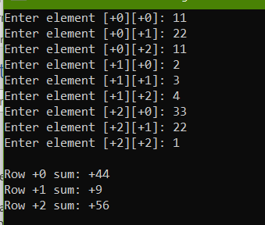

QUESTION 4:

INCLUDE Irvine32.inc

.data
array WORD 11, 0, 23, 5, 65, 00, 72, 11, 92, 10,
11, 12, 13, 14, 15, 16, 37, 58, 19, 22,
27, 52, 23, 64, 27

original BYTE "MY array:", 0
transposed BYTE "Transpose array:", 0

.code
main PROC
call Crlf
mov edx, OFFSET original
call WriteString
call Crlf
call DisplayArray

call TransposeArray

call Crlf
mov edx, OFFSET transposed
call WriteString
call Crlf
call DisplayArray

exit
main ENDP

TransposeArray PROC
mov esi, 0

outer_loop:
cmp esi, 5
jge done_transpose

mov edi, esi
inc edi

l2:
cmp edi, 5
jge l1

mov eax, esi
mov ebx, 5
mul ebx
add eax, edi
mov ecx, eax

mov eax, edi
mov ebx, 5
mul ebx
add eax, esi
mov edx, eax

movzx eax, array[ecx*2]
movzx ebx, array[edx*2]

mov array[ecx*2], bx
mov array[edx*2], ax

inc edi
jmp l2

l1:
inc esi
jmp outer_loop

done_transpose:
ret
TransposeArray ENDP

DisplayArray PROC
mov esi, 0
mov ebx, 0

display:
cmp esi, 25
jge Don

movzx eax, array[esi*2]
call WriteInt

mov al, ' '
call WriteChar
call WriteChar

inc ebx
cmp ebx, 5
jl end

call Crlf
mov ebx, 0

end:
inc esi
jmp display

Don:
ret
DisplayArray ENDP

END main
